Unlocking Insights Into The Global Air Transportation Network With Tableau

**1.INTRODUCTION**

1.1 Overview

Unlocking insights into the global air transportation network with Tableau involves using the Tableau data visualization and business intelligence platform to analyze and present data related to the air travel industry. Here's an overview of the process

1.2 Purpose

Unlocking insights into the global air transportation network with Tableau can serve various purposes, including:

1. Optimizing Operations: Airlines and airports can use Tableau to analyze flight data, passenger trends, and delays, allowing them to optimize schedules, reduce bottlenecks, and improve efficiency.

2. Enhancing Safety: By visualizing safety data, aviation authorities can identify trends and areas of concern, enabling them to take proactive measures to enhance safety in air travel.

3. Cost Reduction: By examining fuel consumption, maintenance, and other cost-related data, airlines can identify areas for cost reduction, contributing to higher profitability.

4. Regulatory Compliance: Aviation organizations can use Tableau to monitor compliance with regulations and report data to relevant authorities effectively.

5. Market Analysis: Airlines and investors can utilize Tableau to analyze market trends, competition, and demand, aiding in strategic decision-making.

2.1 Empathy Map

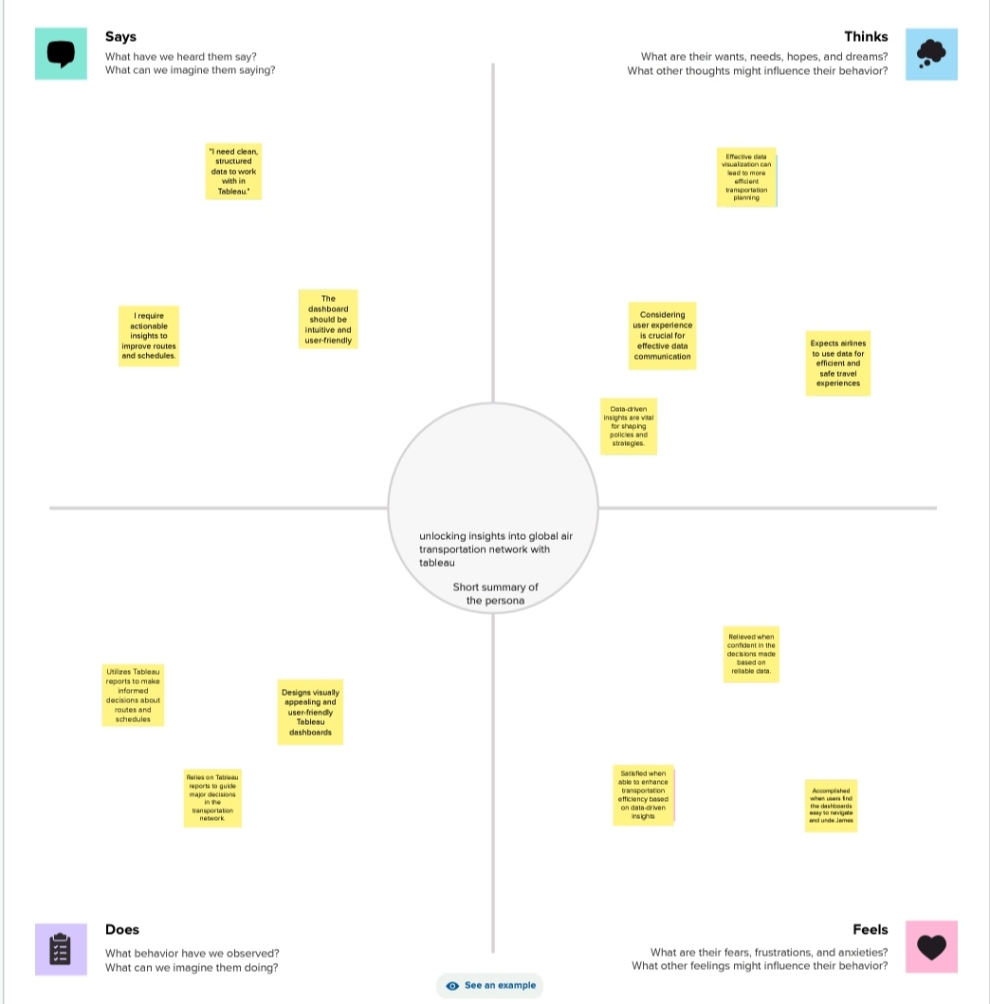

2.2 Ideation & Brainstorming Map

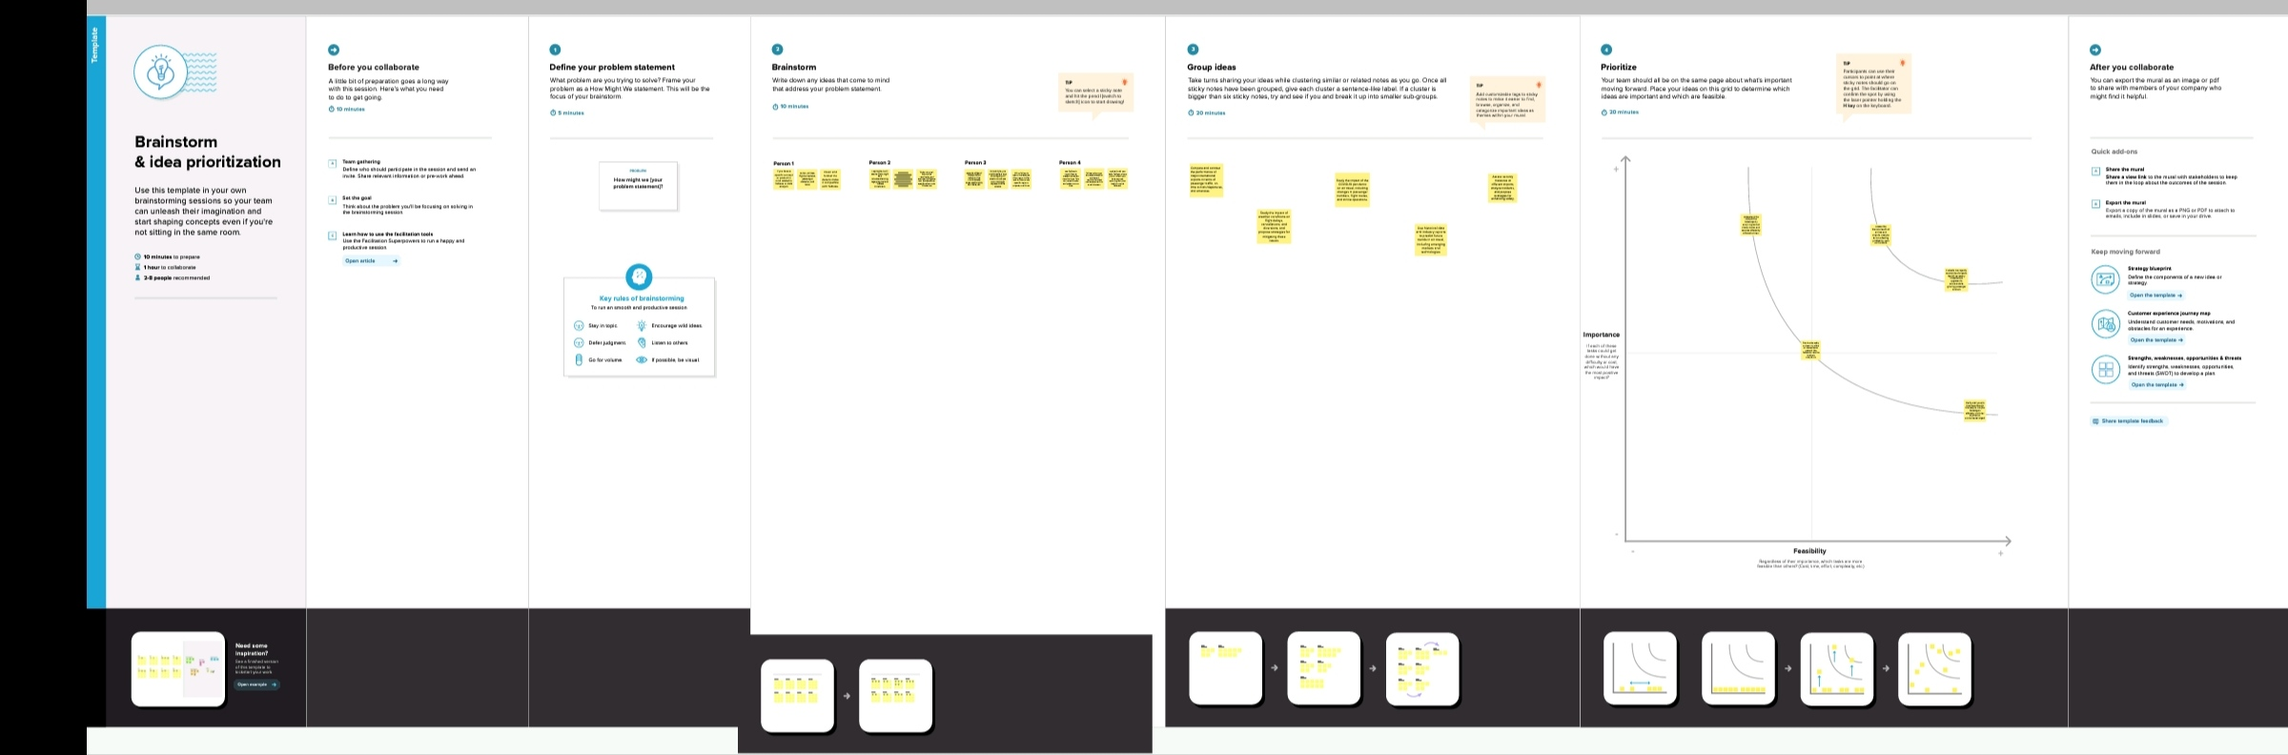

**3.RESULT**

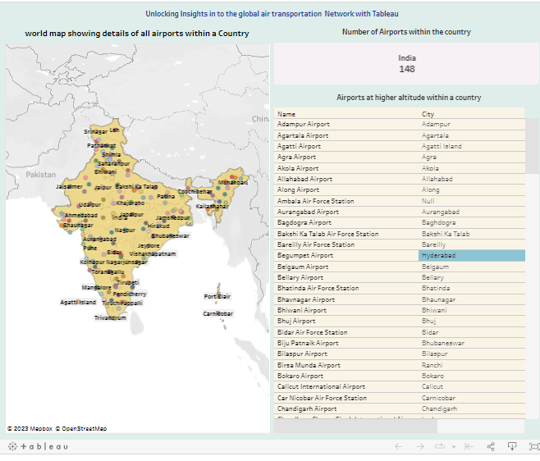

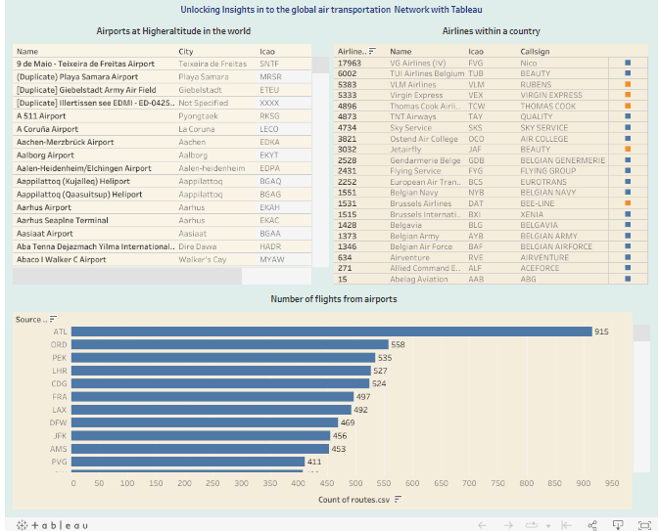

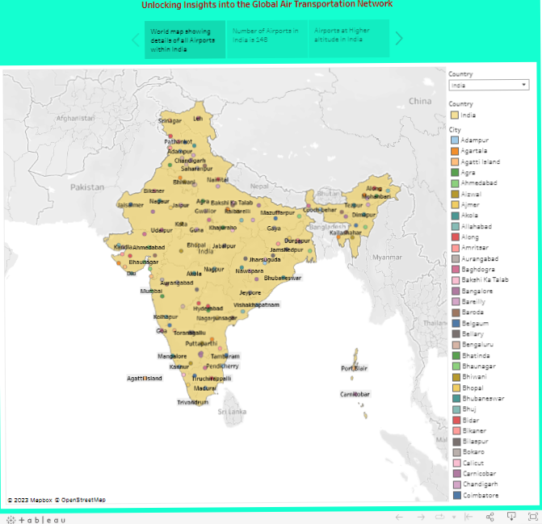

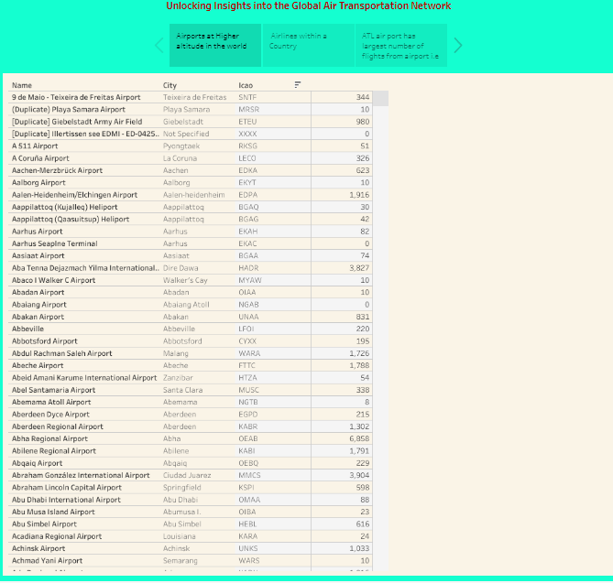

**4.ADVANTAGES**

1. Data-Driven Decision-Making: Tableau enables data visualization and analysis, allowing aviation professionals to make informed decisions based on real-time and historical data.

. Operational Efficiency: Airlines and

2 airports can optimize routes, schedules, and resource allocation, reducing costs and improving overall efficiency.

3. Safety Improvements: By analyzing safety data, aviation authorities can identify potential risks and take proact↓ measures to enhance safety in air travel List of advantages and disadvantages of the proposed solution

4. Customer Experience Enhancement:

Airlines can tailor services, pricing, and routes based on customer preferences and feedback, leading to an improved passenger experience.

5. Cost Reduction: Insights from Tableau can help airlines identify cost-saving opportunities, such as fuel efficiency improvements and maintenance optimization.

6. Regulatory Compliance: Ensure compliance with industry regulations and provide accurate and timely reporting to authorities.

7. Market Competitiveness: Gain competitive edge by analyzing market trends and competition, enabling airlines to adapt and innovate in response to changing conditions.

8. Environmental Impact Reduction: By visualizing carbon emissions and other environmental data, the aviation industry

**DISADVANTAGES**

1. Data Security and Privacy Concerns:

Managing and sharing sensitive air transportation data can raise security and privacy issues, especially when dealing with passenger information, which must be handled with care to comply with regulations.

2 . Data Complexity: The aviation industry generates vast and complex datasets. Analyzing this data with Tableau can be challenging and may require extensive computing resources and expertise.

3. Initial Investment: Implementing Tableau and associated infrastructure can be costly and may require a significant initial investment, making it challenging for smaller organizations to adopt.

4. Training and Expertise: To utilize Tableau effectively, aviation professionals may need specialized training and expertise, which can be time-consuming and expensive to acquire.

5. Integration Challenges: Integrating

Tableau with existing systems and databases can be complex, potentially causing disruptions and incompatibility issues.

6. Data Quality: Insights are only as good the data they are based on. Poor data

**APPLICATIONS**

1 . Route Optimization: Airlines can use Tableau to analyze historical flight data, weather patterns, and fuel costs to optimize flight routes and schedules, reducing operational costs and increasing efficiency.

Passenger Experience Enhancement: By analyzing customer feedback, booking trends, and in-flight data, airlines can improve services, seat allocation, pricing, and onboard amenities to enhance the↓ passenger experience.

3. Operational Efficiency: Airports and airlines can monitor and analyze data on aircraft turnaround times, gate availability, baggage handling, and other operational aspects to minimize delays and improve efficiency.

4. Safety and Compliance: Aviation authorities can use Tableau to monitor safety data, compliance with regulations, and incident reports to enhance safety in air travel and ensure adherence to industry standards.

5. Maintenance Planning: Airlines can predict maintenance needs and optimize maintenance schedules by visualizing data related to aircraft health and performance, reducing downtime and maintenance costs

6. Market Analysis: Airlines can analyze market trends, competition, and passenger demand to make informed decisions about expanding routes.

**CONCLUSION**

In conclusion, unlocking insights into the global air transportation network with Tableau is a powerful and multifaceted endeavor that offers numerous benefits and opportunities for the aviation industry. By harnessing the capabilities of Tableau, aviation professionals can make data- driven decisions, optimize operations, enhance safety, improve the passenger experience, and address various challenges. From route optimization and cost reduction to environmental impact reduction and disaster response, Tableau empowers the aviation sector to adapt, innovate, and serve the needs of passengers and stakeholders more effectively.